2025
Subash Subedi

VLANs: From Theory to Packet-Level Analysis with GNS3 and Wireshark
From Theory to Packet-Level Reality Perfect for Real-World Engineers
Abstract
This hands-on guide provides a complete understanding of IEEE 802.1Q VLANs using a practical GNS3 topology with one Cisco Layer 2 switch and seven PCs. The document explains VLAN theory, switch configuration, tagging and untagging behavior, and packet-level verification using Wireshark.

A Local SPAN (Switched Port Analyzer) session is used to mirror VLAN traffic to a dedicated monitoring port. This allows accurate observation of 802.1Q header behavior on access ports, trunk ports, and native VLAN traffic.
By completing this lab, learners gain both theoretical and practical understanding required for CCNA and real-world network troubleshooting.

Table of Contents
1. Introduction 4
1.1. What is a VLAN? 4
1.2. Why VLANs Are Important 4
1.3. Benefits of VLANs in Modern Networks 5
2. VLAN Core Concepts 5
2.1. Broadcast Domains & Network Segmentation 5
2.2. Tagged vs Untagged Traffic 6
2.3. IEEE 802.1Q Standard Overview 6
2.4. The Native VLAN Concept 6
2.5. VLAN IDs and Ranges 7
3. VLAN Types 7
3.1. Static VLANs (Port-Based) 7
3.2. Dynamic VLANs 7
3.3. Voice VLAN (Auto & Manual) 7
3.4. Management VLAN & SVI 8
3.5. Default VLAN (VLAN 1) 8
3.6. Private VLANs 8
4. Switch Port Modes 9
4.1. Access Port 9
4.2. Trunk Port (ISLCisco & IEEE 802.1Q) 9
4.3. Dynamic Auto / Dynamic Desirable (DTP Modes Table) 9
4.4. How Switches Decide: Tagging vs Untagging Rules (Decision Matrix) 10
5. Hands-On Lab: VLAN Implementation in GNS3 11
5.1. Lab Objectives 11
5.2. Lab Topology Overview 11
5.3. Devices and Software Used 11
5.4. VLAN & IP Allocation Table 11
5.5. Step-by-Step Switch Configuration 12
5.5.1. Creating VLANs 12
5.5.2. Configuring Access Ports 13
6. SPAN (Switched Port Analyzer) Configuration 17
6.1. Why Use SPAN in VLAN Labs 17
6.2. Updated Topology with Monitoring Port 17
6.3. Complete SPAN Configuration 17
6.4. Verifying SPAN Session 18
6.5. What You Should See in Wireshark 18
6.6. Tag Behavior Summary Table 18
7. Traffic Capture & VLAN Tag Analysis 19
7.1. Access-Port Traffic --> Untagged 19
7.2. Trunk Traffic --> Tagged (VLAN 10) 19
7.3. 802.1Q Header Breakdown in Wireshark 19
7.4. Native VLAN Traffic --> Untagged on Trunk 19
7.5. Sample Packet Capture 20
8. Key Observations & Learning Outcomes 20
9. Best Practices & Security Recommendations 20
10. Troubleshooting VLAN Issues 20
10.1. Top 5 VLAN Problems on the Exam 20
10.2. Native VLAN Mismatch Symptoms 21
10.3. Must-Know Commands + Expected Output 21
11. Conclusion 21

Introduction

What is a VLAN?
A Virtual LAN (VLAN) is a logical grouping of devices within a switched network that allows them to communicate as if they were on the same physical segment, even if they are connected to different switches or located on different floors.

VLANs rely on logical connections rather than physical ones. Devices in the same VLAN share a broadcast domain, meaning that unicast, broadcast, and multicast traffic are restricted to that VLAN. Devices in different VLANs cannot communicate directly at Layer 2; communication between VLANs requires a Layer 3 device, such as a router.

Example: In a three-floor office, IT, HR, and Sales departments may each have their own VLAN (VLAN 2, 3, and 4). These VLANs span all floors, allowing devices to communicate logically while remaining physically connected to different switches.

Why VLANs Are Important
VLANs are essential because they:
Segment networks logically by function, department, or application, regardless of physical location.
Reduce broadcast domains, preventing unnecessary traffic from reaching all devices and improving performance.
Contain broadcast traffic within each VLAN, improving efficiency and scalability.
Enhance security and access control by isolating sensitive users or departments (e.g., HR, IT) from general users (e.g., Guests, Students).
Enable flexible network design, allowing devices to be moved or added without rewiring or creating new physical networks.

Benefits of VLANs in Modern Networks
The main advantages of VLAN implementation include:

Improved Performance
Smaller broadcast domains reduce unnecessary traffic and increase network efficiency.

Enhanced Security
Logical isolation prevents unauthorized access between VLANs, protecting sensitive departments.

Better Organization and Flexibility
Devices can be grouped by role or function rather than physical location, simplifying moves and expansions.

Simplified Network Management
Supports hierarchical IP addressing, making administration and troubleshooting easier.

Cost Efficiency
Reduces the need for multiple physical networks and equipment while maintaining logical separation.

Policy Enforcement
Access control and traffic rules can be applied per VLAN, such as restricting Guest VLANs to internet-only access.

VLAN Core Concepts

Broadcast Domains & Network Segmentation
A broadcast domain is a set of devices that receive a Layer 2 broadcast frame.
Without VLANs: the entire switched network is one broadcast domain - any broadcast is sent to all devices, causing unnecessary traffic.
With VLANs: each VLAN forms a separate broadcast domain. Broadcasts are limited to devices in the same VLAN, even across different switches.
Result: smaller broadcast domains → improved network performance, scalability, and security.

Tagged vs Untagged Traffic
Untagged traffic: Standard Ethernet frames without VLAN information (from PCs or standard devices).

Tagged traffic: Frames with a 4-byte 802.1Q tag inserted between Source MAC and Type/Length fields, carrying the VLAN ID (VID).

Access ports: Send/receive untagged frames (single VLAN).

Trunk ports: Carry tagged frames for multiple VLANs.

Exception: Traffic in the native VLAN is sent untagged, even on trunks.

IEEE 802.1Q Standard Overview
IEEE 802.1Q is the industry-standard protocol for VLAN tagging on Ethernet networks.
It inserts a 4-byte tag into the original Ethernet frame header containing:
TPID (Tag Protocol Identifier): 2 bytes, value 0x8100
Priority (PRI): 3 bits for Class of Service (QoS)
CFI: 1 bit (legacy Token Ring support)
VID (VLAN ID): 12 bits, supporting up to 4096 VLANs (0–4095)
After tagging, the switch recalculates and updates the Frame Check Sequence (FCS). 802.1Q enables trunk links to transport traffic from multiple VLANs between switches and other devices.s.

The Native VLAN Concept
Each 802.1Q trunk has a native VLAN (default = VLAN 1).
Untagged frames received on a trunk are assigned to the native VLAN.
Frames for the native VLAN are sent untagged across the trunk.
Important points:
Cisco switches drop incoming tagged frames that match the native VLAN ID.
Control protocols (CDP, STP, VTP, DTP) typically use the native VLAN and are sent untagged.
Security best practice: Change the native VLAN to an unused VLAN (e.g., 999) and do not carry user traffic on it.
Native VLAN must match on both ends of the trunk; mismatch causes errors and warnings.

VLAN IDs and Ranges
Normal VLANs: 1–1005 (stored in vlan.dat, supported on all Cisco switches)
Extended VLANs: 1006–4094 (supported on modern switches in VTP transparent mode)
Reserved IDs: 0 and 4095 cannot be used
Total VLANs possible with 802.1Q: 4096 (12-bit VID field)

VLAN Types

Static VLANs (Port-Based)
The most common and recommended method.
Ports are manually assigned to a specific VLAN using switchport access vlan X command.
Reliable, secure, and easy to understand - this is the primary method tested in CCNA.

Dynamic VLANs
VLAN assignment is based on the device’s MAC address using a VLAN Membership Policy Server (VMPS).
Rarely used today and officially deprecated by Cisco - no longer part of CCNA but may appear in CCNP ENCOR.

Voice VLAN (Auto & Manual)
Allows a single switch port to support both a PC (data) and an IP phone (voice).
The port is configured with one data VLAN and one voice VLAN.
Cisco IP phones use CDP or LLDP to learn the voice VLAN and tag voice traffic accordingly.
Configuration example:
switchport mode access
switchport access vlan 20
switchport voice vlan 150

Management VLAN & SVI
A dedicated VLAN used for switch management (SSH, Telnet, SNMP, etc.).
Should not be VLAN 1 for security reasons.
A Switch Virtual Interface (SVI) is created using:
interface vlan 99
ip address 192.168.99.10 255.255.255.0
This provides Layer 3 access to the switch.

Default VLAN (VLAN 1)
All switch ports belong to VLAN 1 by default.
VLAN 1 cannot be deleted or renamed.
Carries all control plane traffic (CDP, STP, VTP, DTP, etc.).
Best security practice:
Do not use VLAN 1 for user or management traffic
Change the native VLAN on trunks
Create separate management and user VLANs

Private VLANs
Advanced feature for further Layer 2 isolation within a single VLAN.
Used in service provider or multi-tenant environments.
Types of ports:
Isolated: Can only communicate with promiscuous ports
Community: Can communicate with other members of the same community and promiscuous ports
Promiscuous: Typically connected to router/firewall

Switch Port Modes

Access Port
Belongs to exactly one VLAN.
Sends and receives only untagged frames.
Used for end devices (PCs, printers, IP phones).

Configuration:
switchport mode access
switchport access vlan X
Strongly recommended to explicitly configure mode access (security).

Trunk Port (ISLCisco & IEEE 802.1Q)
Carries traffic for multiple VLANs.
Uses tagging to identify VLAN membership.
ISL (Cisco proprietary) - deprecated.
802.1Q (IEEE standard) - current standard used everywhere.

Configuration:
switchport mode trunk
switchport trunk native vlan 999
switchport trunk allowed vlan 10,20,30

Dynamic Auto / Dynamic Desirable (DTP Modes Table)
Dynamic Trunking Protocol (DTP) negotiates trunking:
dynamic desirable: Actively tries to form a trunk - trunks with trunk, desirable, or auto
dynamic auto: Passively waits - trunks only if partner is trunk or desirable
trunk: Permanently trunking
access: Permanently access (no trunking)
Best practice: Disable DTP with switchport nonegotiate

How Switches Decide: Tagging vs Untagging Rules (Decision Matrix)
When a frame enters a port:
Access port ---> untagged frame assigned to configured access VLAN
Trunk port ---> tagged frame forwarded based on VID
Trunk port ---> untagged frame assigned to native VLAN

When a frame exits a port:
Access port ---> always sent untagged
Trunk port ---> tagged (except native VLAN traffic → sent untagged)
Port Type | Incoming Frame | Switch Action | Outgoing Frame
Access | Any | Assign to access VLAN | Untagged
Trunk | Tagged | Forward by VLAN ID | Tagged
Trunk | Untagged | Assigned to native VLAN | Untagged
Trunk | Native VLAN | Forward | Untagged
Trunk | Other VLAN | Forward | Tagged

Hands-On Lab: VLAN Implementation in GNS3

Lab Objectives
Create VLAN 10 (IT), VLAN 20 (Finance), VLAN 30 (Sales)
Assign ports to correct VLANs
Configure Management VLAN
Use SPAN to capture frames and verify tagging behavior

Lab Topology Overview
One Cisco L2 switch
Six PCs across three VLANs
One monitoring PC for SPAN

Devices and Software Used
GNS3
Cisco vIOS-L2
Seven VPCS nodes
Wireshark

VLAN & IP Allocation Table
DEPARTMENT | VLAN | Name | IP Address
IT Department | VLAN 10 | PC1-VLAN--10 | 192.168.1.2
IT Department | VLAN 10 | PC2-VLAN--10 | 192.168.1.3
Finance Department | VLAN 20 | ` PC3-VLAN--20 | 192.168.1.4
Finance Department | VLAN 20 | PC4-VLAN--20 | 192.168.1.5
Sales Department | VLAN 30 | PC5-VLAN--30 | 192.168.1.6
Sales Department | VLAN 30 | PC6-VLAN--30 | 192.168.1.7
SPAN (Switched Port Analyzer)  Management | VLAN 99 | Switch SVI | 192.168.1.1

Step-by-Step Switch Configuration

Creating VLANs
enable
configure terminal

vlan 10
name IT Department
exit

vlan 20
name Finance Department
exit

vlan 30
name Sales Department
exit

vlan 99
name Management
exit

do show vlan
do wr

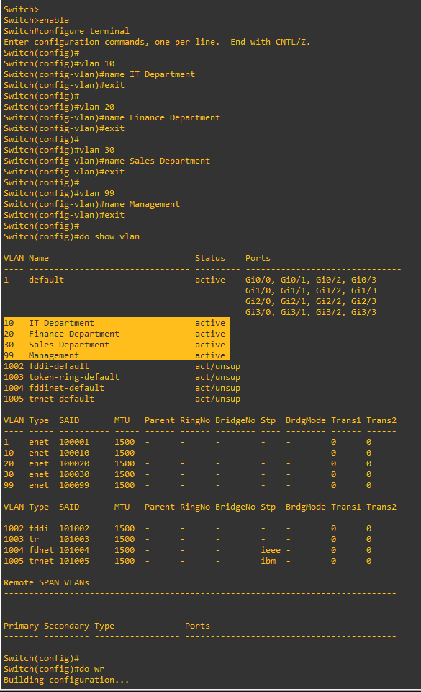

Configuring Access Ports
VLAN 10
enable
configure terminal

interface range GigabitEthernet0/0 - 3
switchport mode access
switchport access vlan 10
description THIS INTERFACE BELONG TO IT DEPARTMENT
no shutdown
exit

do show vlan | include IT

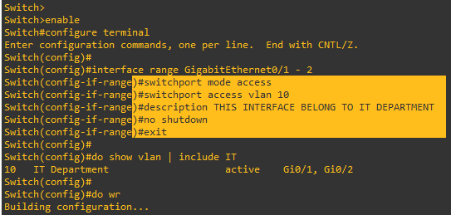

VLAN 20
enable
configure terminal

interface range GigabitEthernet1/0 - 3
switchport mode access
switchport access vlan 20
description THIS INTERFACE BELONG TO FIANANCE DEPARTMENT
no shutdown
exit

do show vlan | include Fi

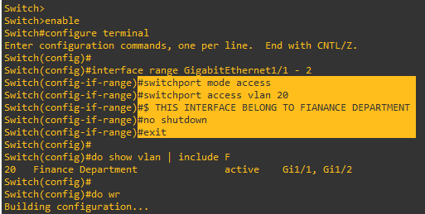

VLAN 30
enable
configure terminal

interface range GigabitEthernet2/0 - 3
switchport mode access
switchport access vlan 30
description THIS INTERFACE BELONG TO SALES DEPARTMENT
no shutdown
exit

do show vlan | include Sales

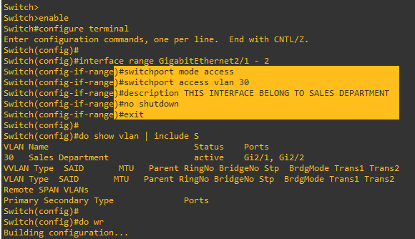

VLAN 99
enable
configure terminal

interface range GigabitEthernet3/0 - 3
switchport mode access
switchport access vlan 99
description THIS INTERFACE BELONG TO MANAGEMENT SVI
no shutdown
exit

do show vlan | include Management

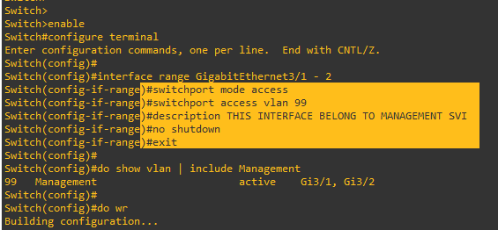

SPAN (Switched Port Analyzer) Configuration

Why Use SPAN in VLAN Labs
To see the truth - prove that access ports really send untagged frames.

Updated Topology with Monitoring Port
PC7 connected to Gi3/1 is used as the SPAN destination port --> receives mirrored traffic.

Complete SPAN Configuration
enable
configure terminal

monitor session 1 source interface Gi0/0 - 3 both

monitor session 1 source interface Gi1/0 - 3 both

monitor session 1 source interface Gi2/0 - 3 both

monitor session 1 destination interface Gi3/1

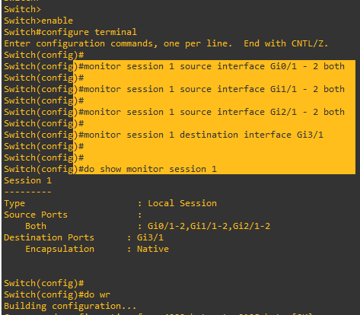

Verifying SPAN Session
show monitor session 1

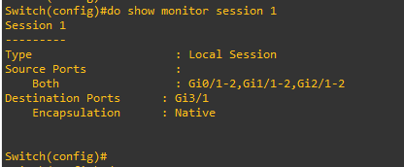

What You Should See in Wireshark
Access port traffic appears untagged
VLAN tag (TPID 0x8100) appears only on trunk links
Native VLAN traffic remains untagged even on a trunk

Tag Behavior Summary Table
Port Type | VLAN Tagging Behavior
Access Port | Always untagged
Trunk Port (Native VLAN) | Untagged
Trunk Port (Non-Native VLANs) | Tagged

Traffic Capture & VLAN Tag Analysis

Access-Port Traffic --> Untagged
We will see normal Ethernet II frames - no “802.1Q Virtual LAN” line in Wireshark.

Trunk Traffic --> Tagged (VLAN 10)
For Trunk Traffics there we should add a second switch --> make link trunk --> we will instantly see TPID 0x8100.

802.1Q Header Breakdown in Wireshark
Priority Code Point (PCP)
Drop Eligible Indicator (DEI)
VLAN Identifier (VID) → e.g., 10, 20, 30

Native VLAN Traffic --> Untagged on Trunk
Even on a trunk, native VLAN frames appear without tags.

Sample Packet Capture
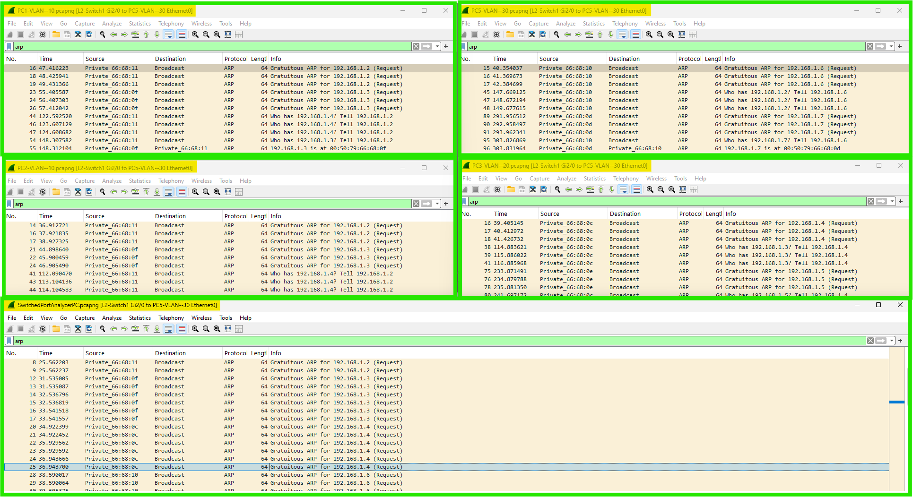

Key Observations & Learning Outcomes
Access ports always strip tags
Trunks preserve tags except for native VLAN
SPAN + Wireshark is the ultimate proof tool
Native VLAN mismatch = real production outages

Best Practices & Security Recommendations
Never use VLAN 1 for user traffic
Change native VLAN on all trunks (switchport trunk native vlan 999)
Disable DTP: switchport nonegotiate
Explicitly set switchport mode access or trunk
Use dedicated management VLAN (not 1)

Troubleshooting VLAN Issues

Top 5 VLAN Problems on the Exam
Native VLAN mismatch
Trunk not allowing required VLANs
Access port in wrong VLAN
DTP negotiation failure
Using VLAN 1 for user traffic

Native VLAN Mismatch Symptoms
%CDP-4-NATIVE_VLAN_MISMATCH logs
STP loops possible

Must-Know Commands + Expected Output
show vlan brief
show interfaces trunk
show interfaces switchport
show monitor session all

Conclusion
This document provides a complete understanding of VLAN configuration, 802.1Q tag behavior, native VLAN operation, and SPAN-based packet analysis. The combination of theory and hands-on practice in GNS3 allows accurate visualization of VLAN operations and prepares learners for both CCNA-level exams and real-world troubleshooting

